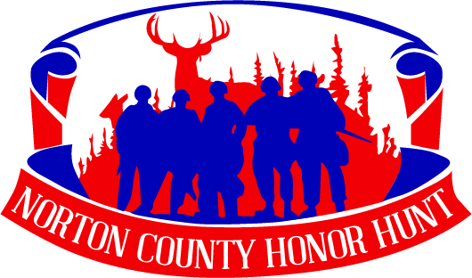

Join Us! American Veterans who are Kansas residents with at least a 30% disability rating are invited to apply for an all-expense paid rifle deer hunt throughout Norton County, KS on December 4-6, 2019.

Name: _______________________________________________________________________________________

Address: _____________________________________________________________________________________

City, State, Zip: ______________________________________________________________________________

E-mail Address: _____________________________________________________________________________

Phone Number: ____________________________________________________________________________
Please provide the best phone number to reach you; you can provide multiple numbers

Branch of Military Service: _________________________________________________________________

Years of Military Service: ___________________________________________________________________

Questions to get to know you:
Please answer on a different paper.

1) Tell us about your years in service.

2) Why would you like to be selected for participation in the 2019 Norton County Honor Hunt?

PLEASE ENCLOSE A COPY OF YOUR DD214 WITH YOUR APPLICATION.

Please Return Applications to: Additional Contact Person:
Tara Vance Ruth Shearer
c/o Norton County Community Foundatio President, NCHH
112 S. Kansas Ave, Suite 308 785.664.8018
Norton, KS 67654 ruth@almenastatebank.net
tara@nortonccf.org

Applications are due by Friday, May 31, 2019.
Applications can be completed online at www.nortoncountyhonorhunt.com.

